**Project 5 - CarND-MPC-Project-master**

For this project, major part is to identify what is the error we wish to minimize, and also the weight on each error also play an important role from my experience.

Also another tedious thing has to highlight here is the environment set up for this project. To be specific, install ipopt really took me more than 1 day figuring out the correct way of doing it, below link is my way of doing that, that is reference working for me:

<https://medium.com/@notus.li/install-ipopt-on-ubuntu-16-04-e2644fa93545>

First part is to define cost function, and here is the hard code:

I would say the error is straight forward, also all has been mentioned inside lecture, but the weight is something has to play around with.

For instance, if “delta_error_weight” is low like 500/ 600, then in my case, car angel for sure will be unstable especially for area turning right/ left.

Even I change into 700, it also not stable, till 800. now it is stable.

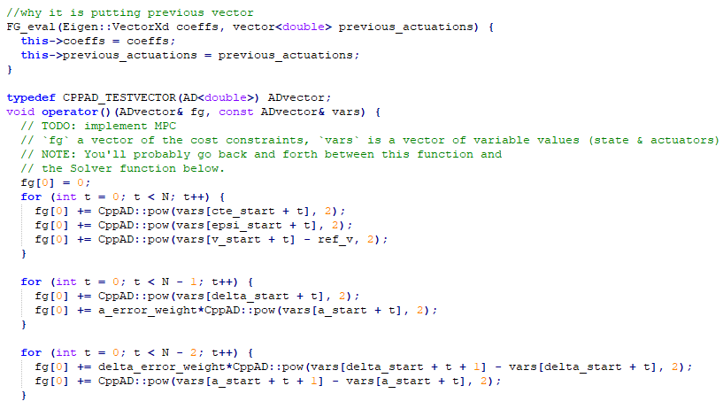

Below is area where we define the route function, you can see the coeffs parameter stands for route function parameter.

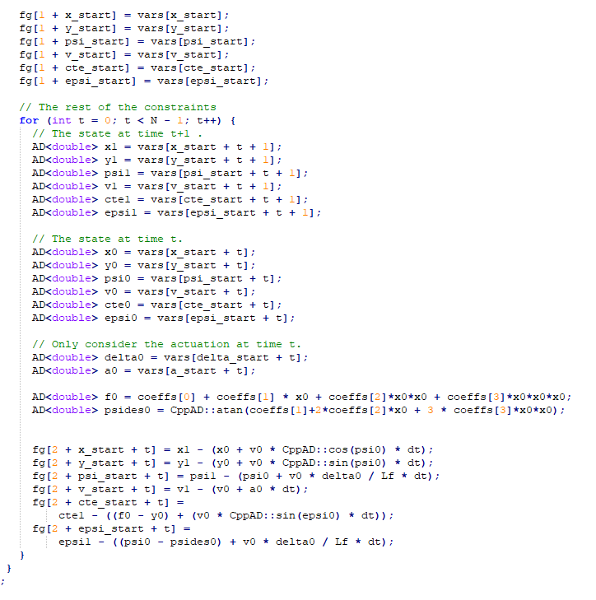

And below is area we give lower & upper bound for each parameter like delta has to be less than 25 degree for both left & right side.

The way I am choosing N & dt is quick straight forward, I didn’t worry too much about dt, just always give the recommended value 0.05, but N really need to modify even based on different speed of the car. The fast max speed is, the low N should be, this is my finding. I tried from 15, down into 14, 13 etc,.in the end 12 meets my expectation. Model can run properly. I feel like if what to modify dt, need to keep in mind N*dt*max_car_speed should not be changing too much. This should be the distance we are using for forecasting future route map, so too long or too short all incorrect. Since we have max x0*x0*x0.

Also I realize one thing, if N & dt can be dynamic based on current speed, then would be the best since at the beginning, once speed is low, a fix N & dt will make N*dt*car_speed short, which will impact the stability of the route forecasting. That is the reason always at the beginning that is not that stable as other time.

In the end, car can run nicely like video attached.

For running the project, you can refer to below steps after your environment setup done:

**- If this is not first time running, remove previous folder first using:**

rm -R CarND-MPC-Project-master

**- You may need to select ‘y’ for certain file while removing folder. Post that, you can run below code to start project running:**

git clone https://github.com/MagicSHX/CarND-MPC-Project-master.git

cd CarND-MPC-Project-master

mkdir build && cd build

cmake .. && make

**- Last step: making sure simulation started before running below code in ubuntu:**

./mpc